Day 24

DIY

Q1. Problem Statement: Moving an Airline data From S3 to AWS Redshift and Query the data via Redshift Editor

Use Case:

In a physical world, we have physical warehouses where goods, ferried and transported from multiple locations, are stored. Data Warehouse have a similar model but work on a virtual infrastructure, and it is all about the movement and the storage of data in a safe location. The data is gathered from different applications onto a Data warehouse which is later processed using efficient analytics tools to draw meaningful insights from the aggregated data.Setting up a Data warehouse takes a lot of time, efforts and resources.

AWS Redshift is a managed Data warehouse from AWS, which makes it easy to setup a Data warehouse in the AWS Cloud. In this exercise, we would be setting a Redshift Cluster, moving a synthetic Airline data from S3, and performing some analytics in Redshift.AWS Redshift falls under the trial version and is free for two months from the time the cluster is created for the first time. Note that it does not account for when an AWS account was created. Only a dc2.large node falls under the trial version and it’s just one node.

Solution -

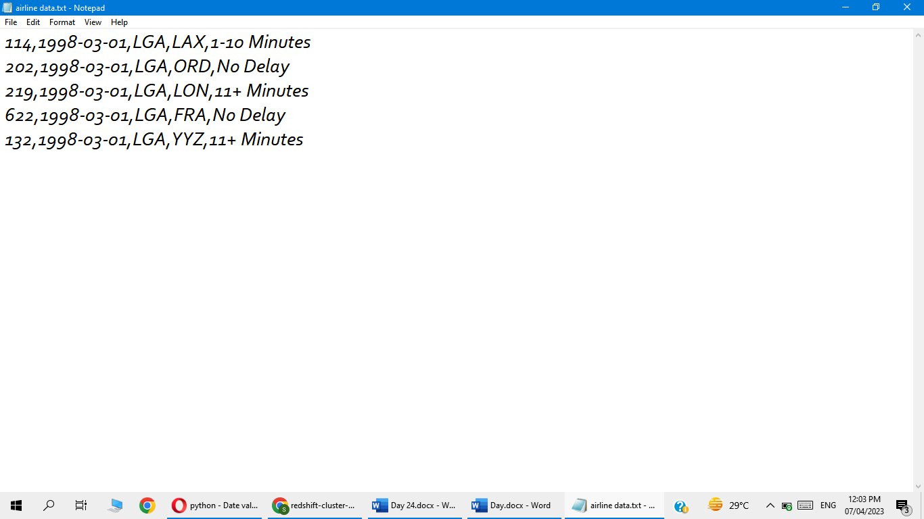

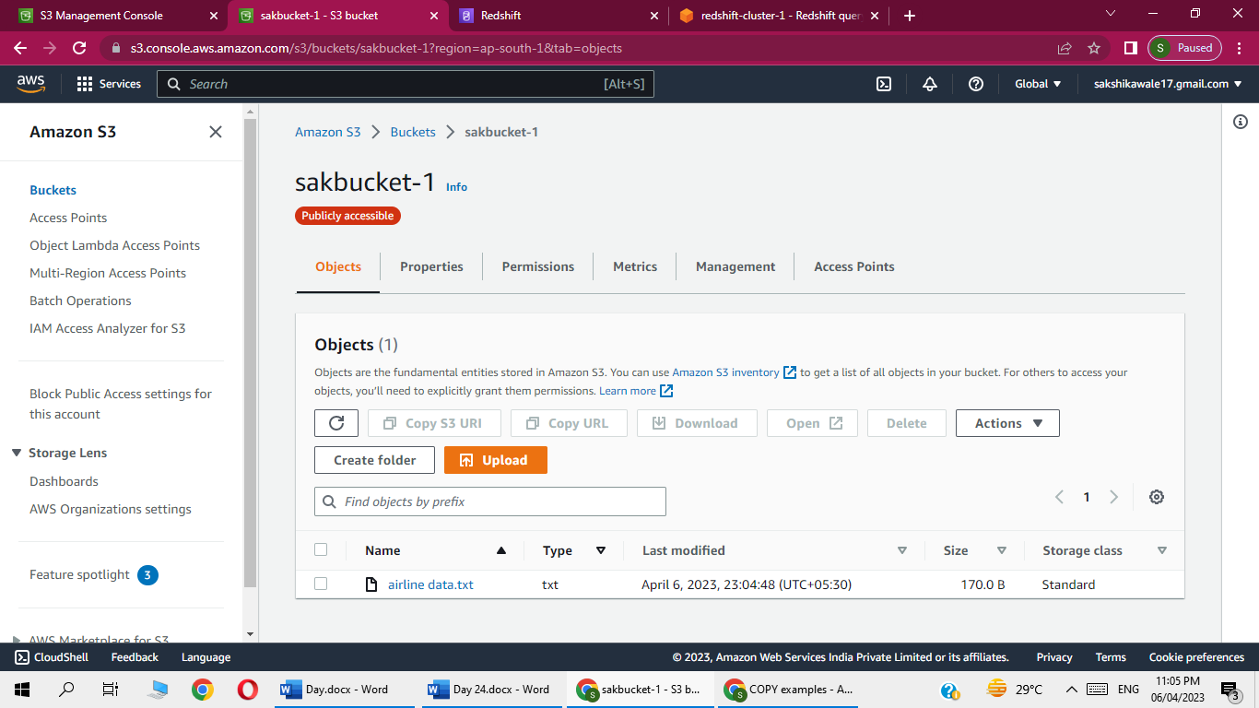

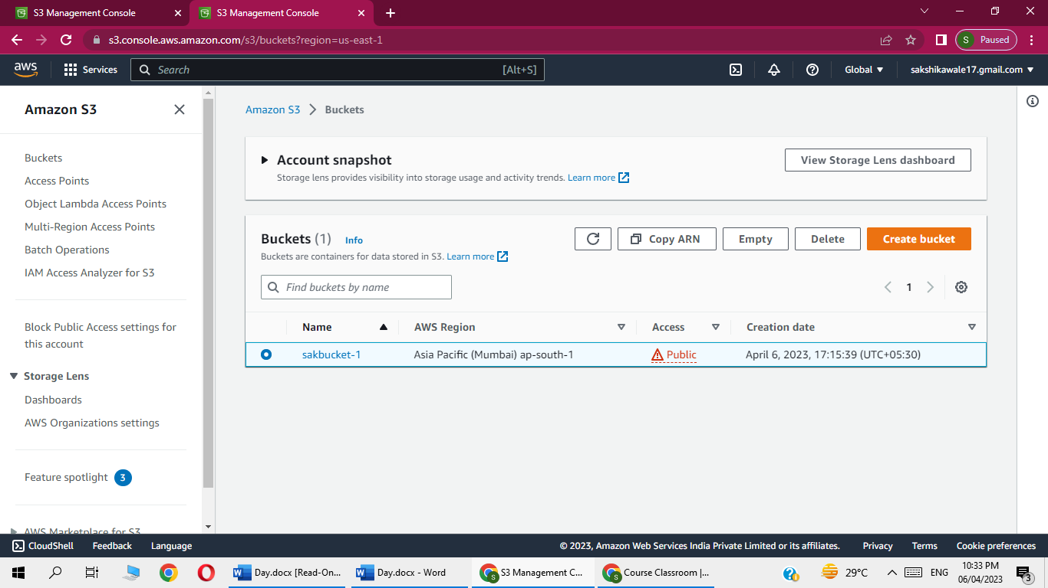

Go to iam role

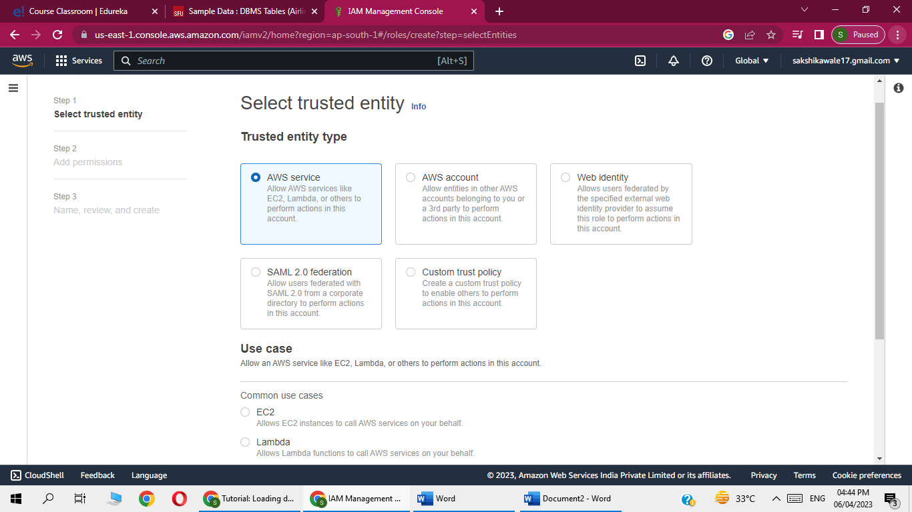

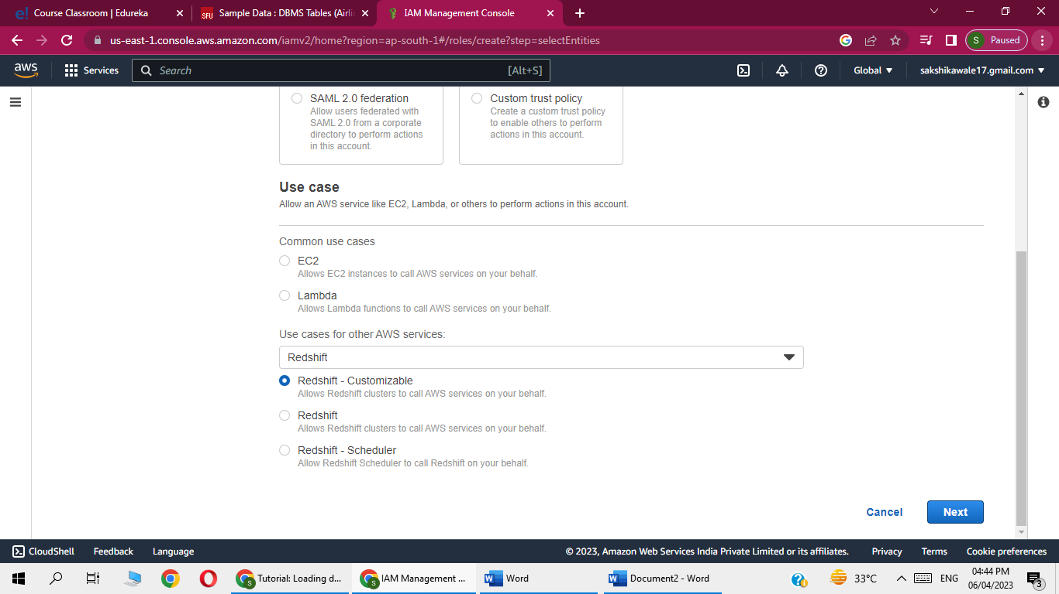

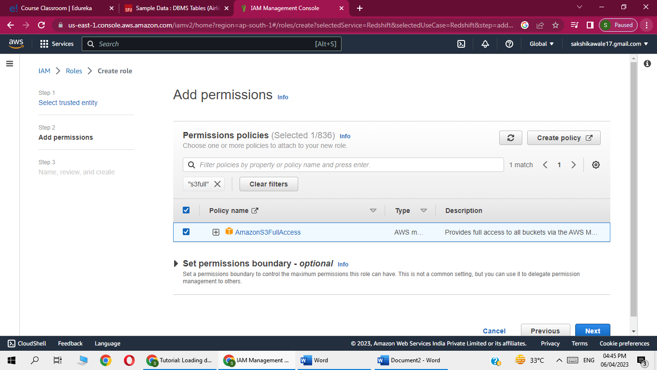

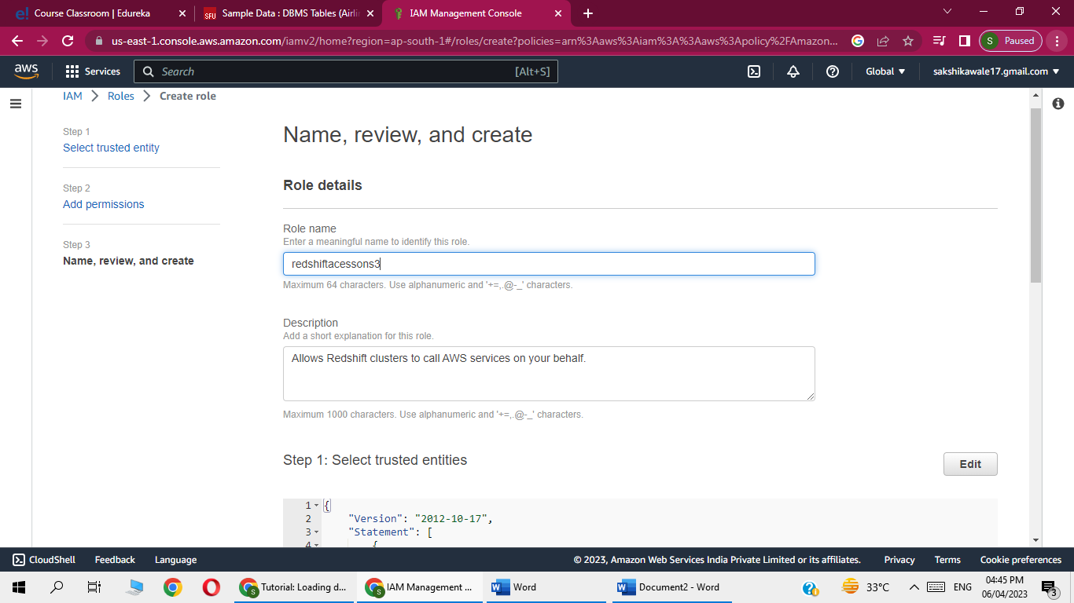

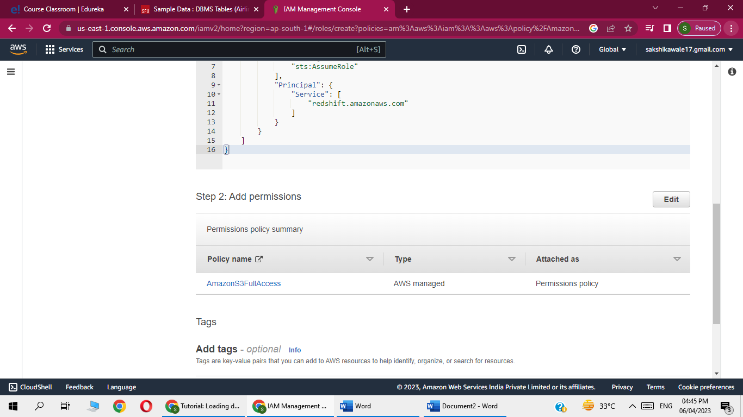

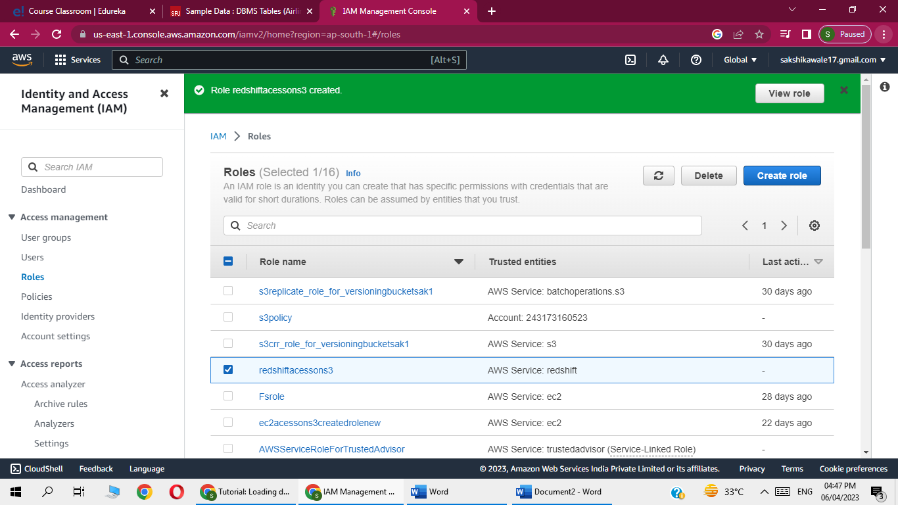

Go to redshift

-Create cluster

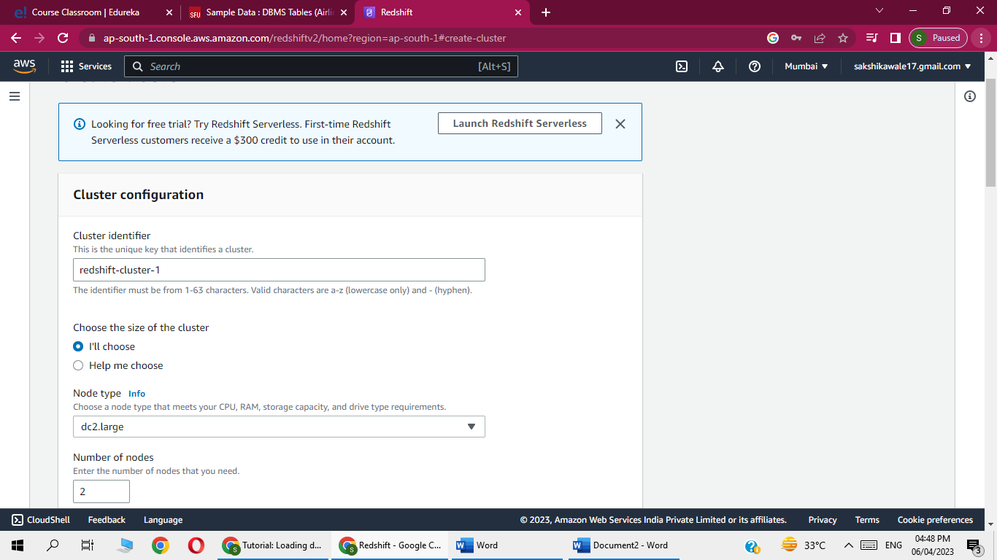

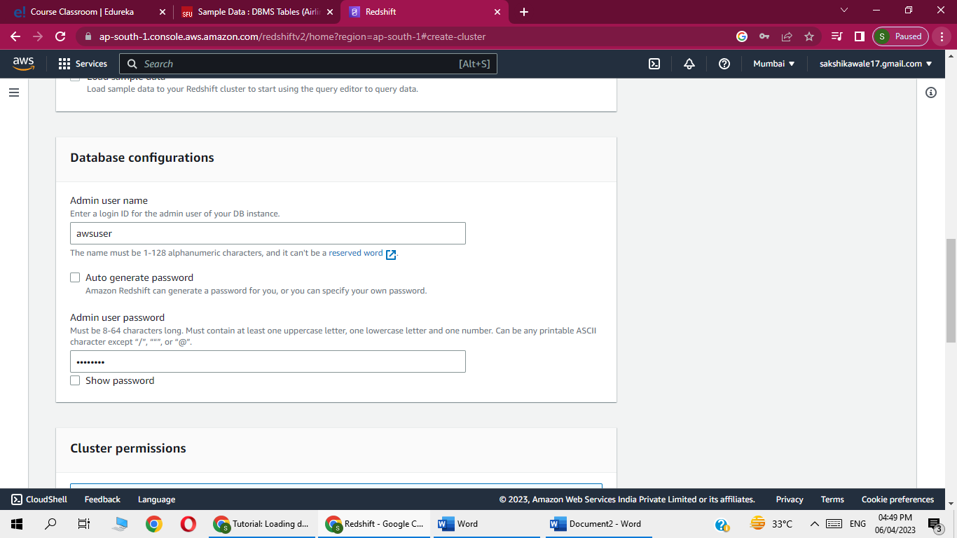

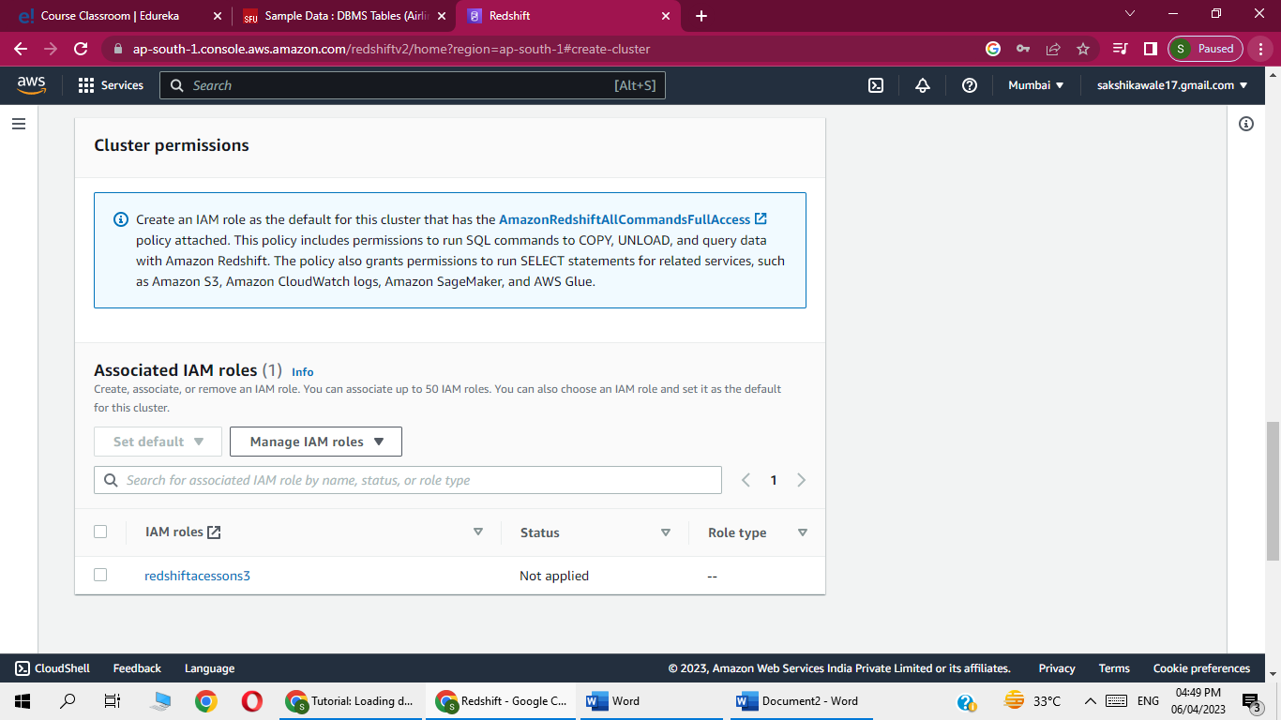

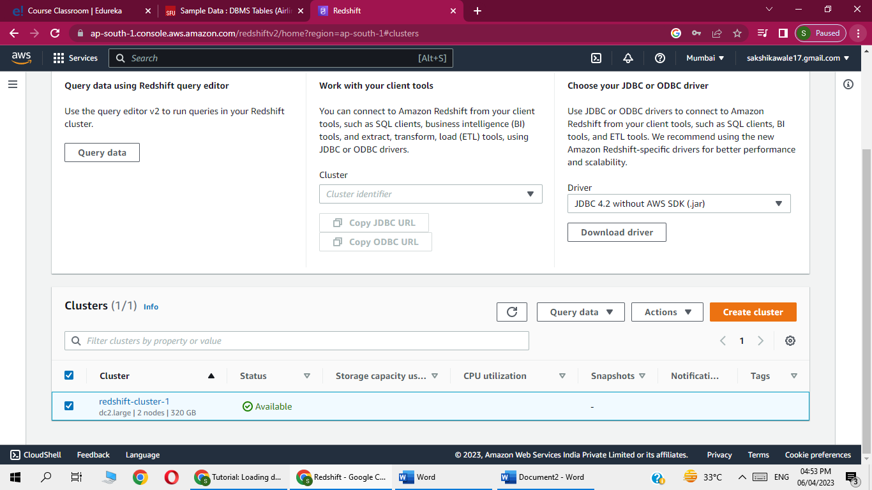

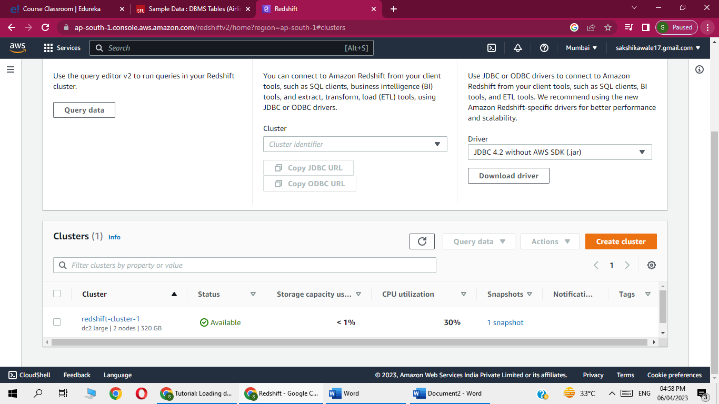

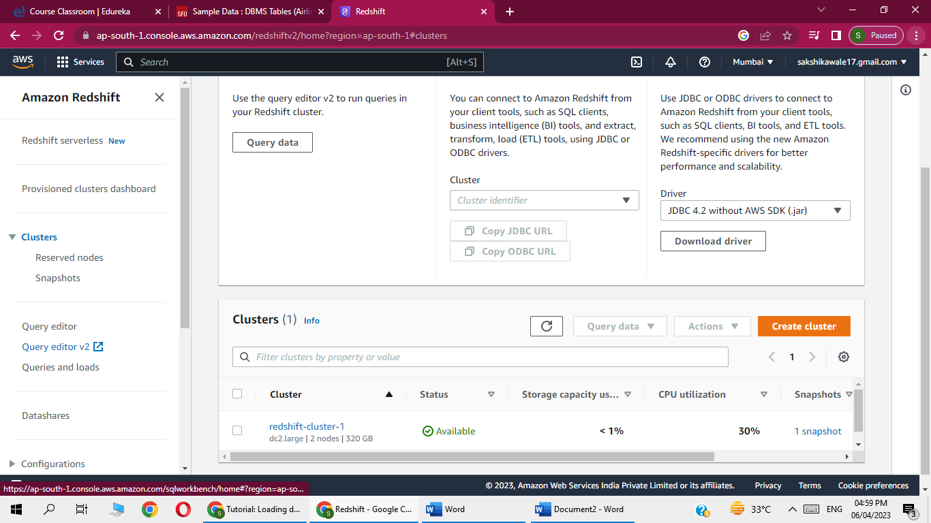

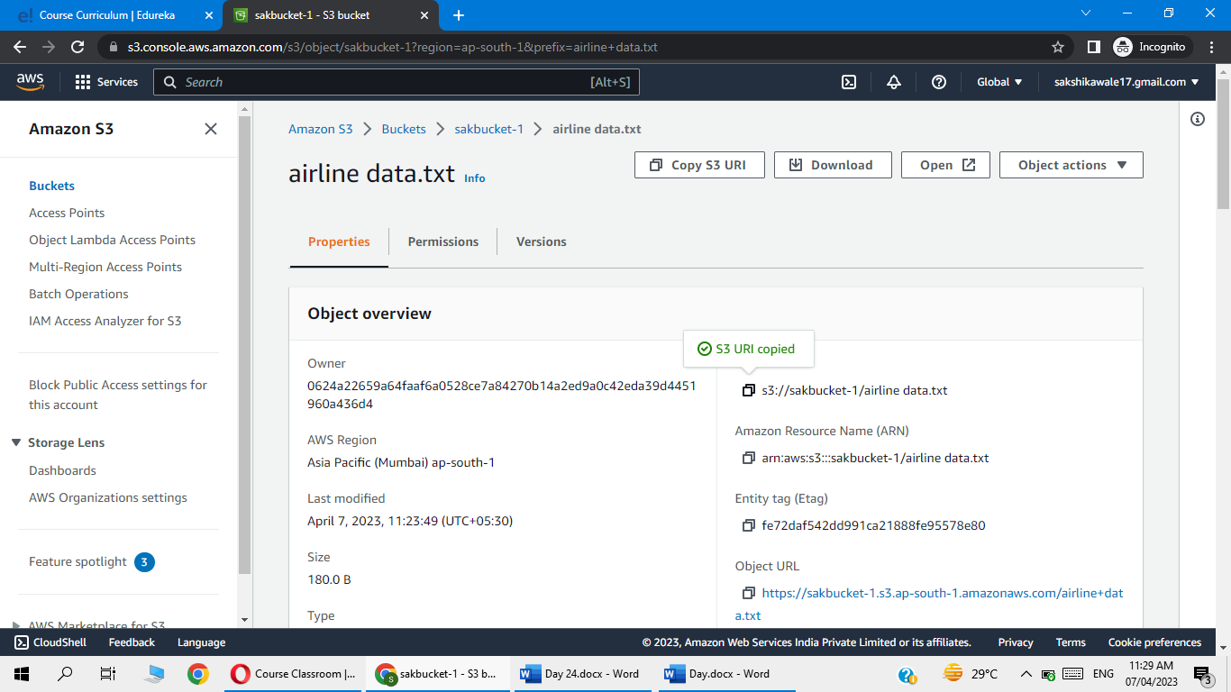

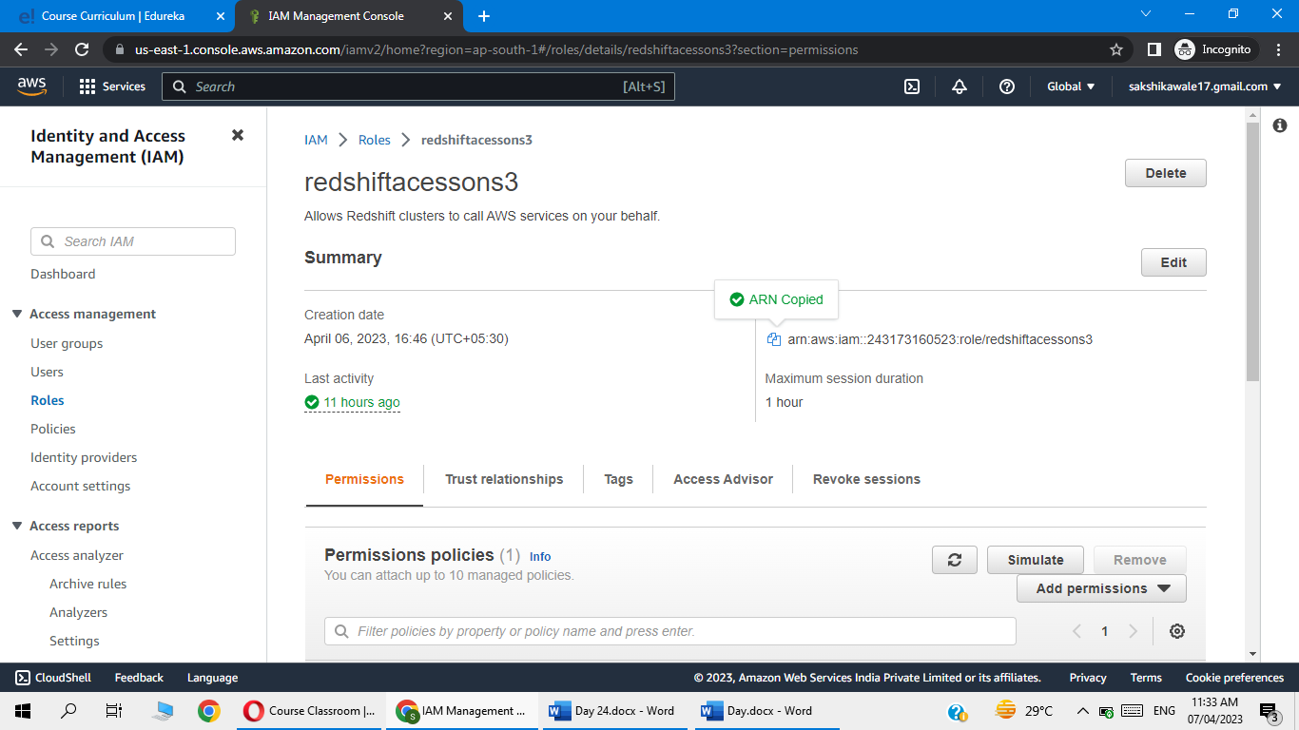

Now go to redshift and open vi editor

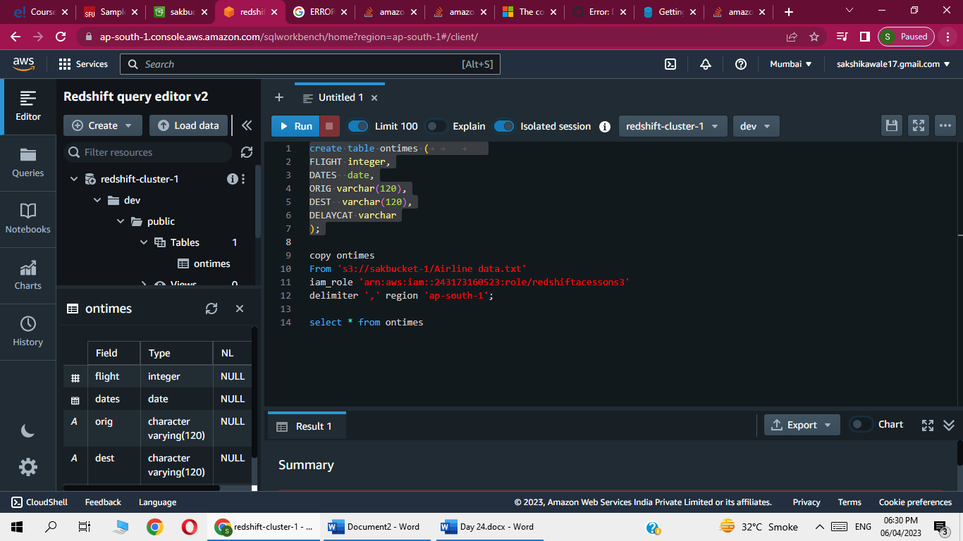

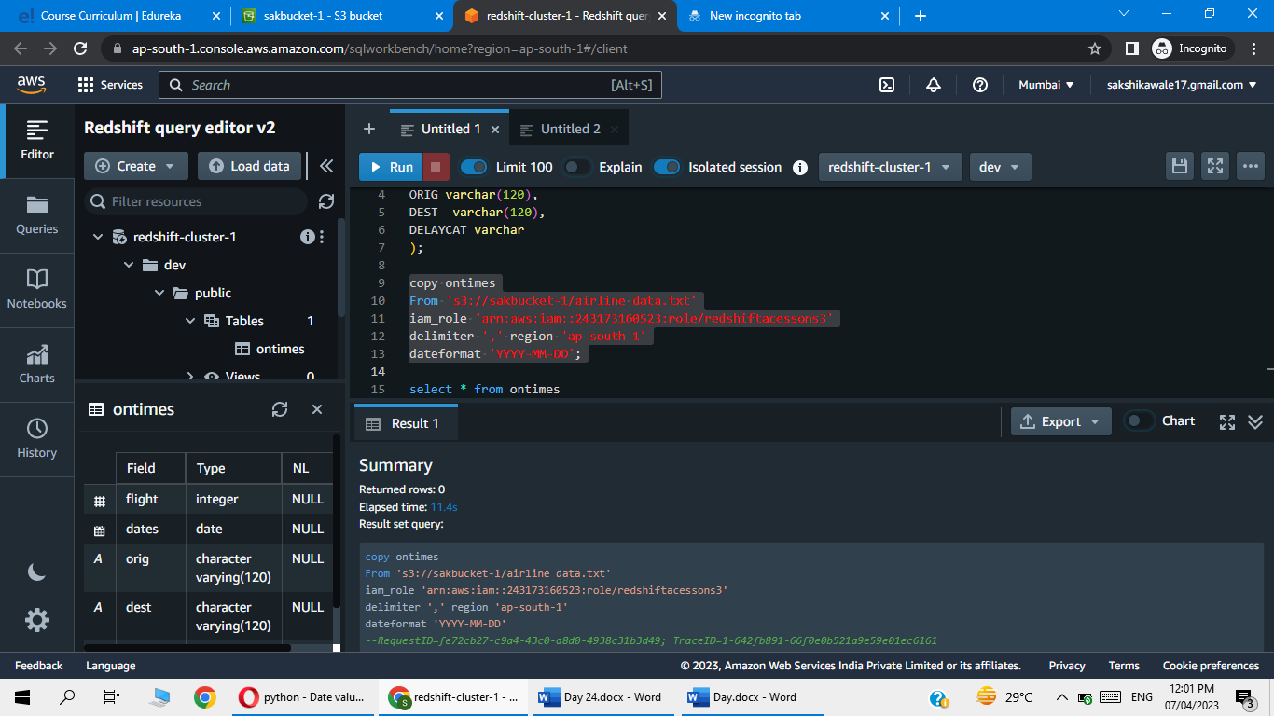

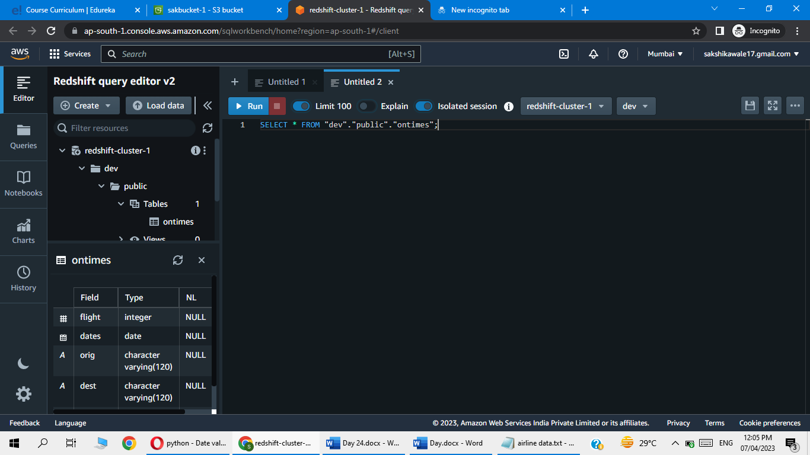

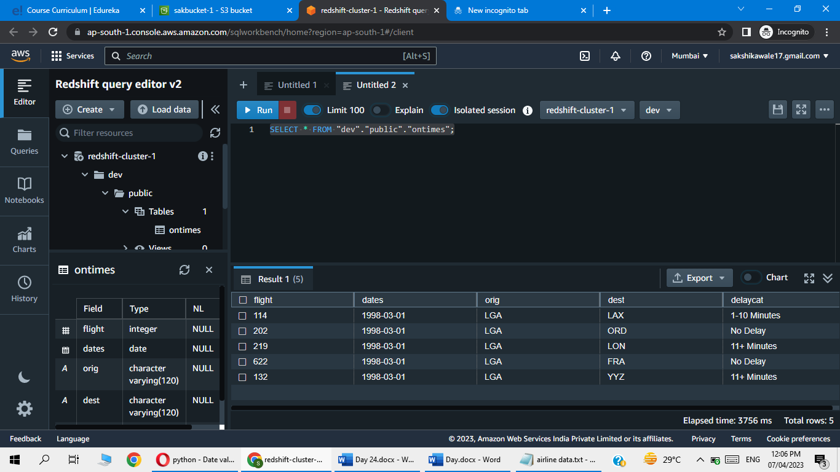

Successfully, Moving an Airline data From S3 to AWS Redshift and Query the data via Redshift Editor